**Software Engineering Semester 3**

**Design Document**

**Online Yearbook**

June 2021

Spartex

|  |
| --- |
| **Date:** **05/06/2021** |
| **Version:2.0** |
| **State:** Almost Completed |
| **Author: Osuntuyi Michael** |

Version history

|  |  |  |  |  |
| --- | --- | --- | --- | --- |
| **Version** | **Date** | **Author(s)** | **Changes** | **State** |
| 1.0 | 18/05/2021 | Osuntuyi Michael | Document was made | Complete |
| 2.0 | 05/06/2021 | Osuntuyi Michael | Document was edited | Almost Completed |
|  |  |  |  |  |

Table of Contents

Introduction: 3

C4 diagrams 3

Level1: How it works in a nutshell (Context) 3

Level2: Containers 3

Level3: Architecture diagram 4

Diagram Link 4

Level4: Code structure and DB Design(UML, ERD 5

Diagram Link 6

BackEnd 7

Java Spring boot Framework: 7

BCrypt for encryption 7

Hibernate 7

Spring Security 7

References 7

Sonarqube Screenshot (Quality assurance metrics) 8

CI CD Setup 8

# Introduction:

This document contains all valuable information about the Architecture, Technologies and Integrity status of the current onlineyearbook project version

# C4 diagrams

## Level1: How it works in a nutshell (Context)

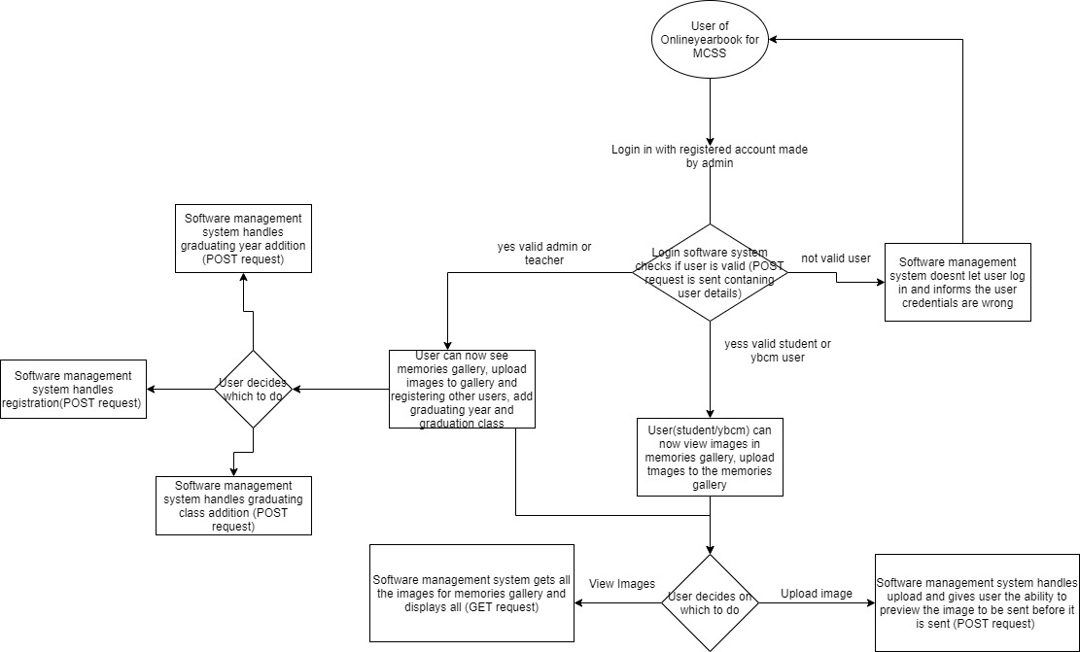

## Level2: Containers

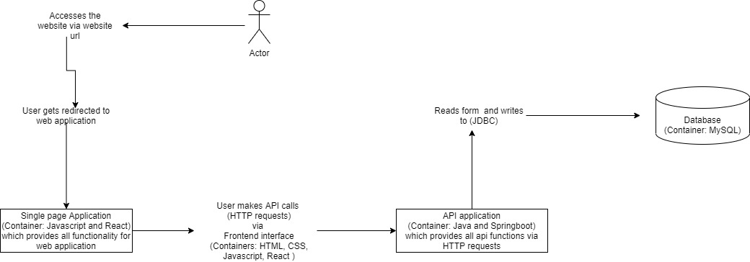

## Level3: Architecture diagram

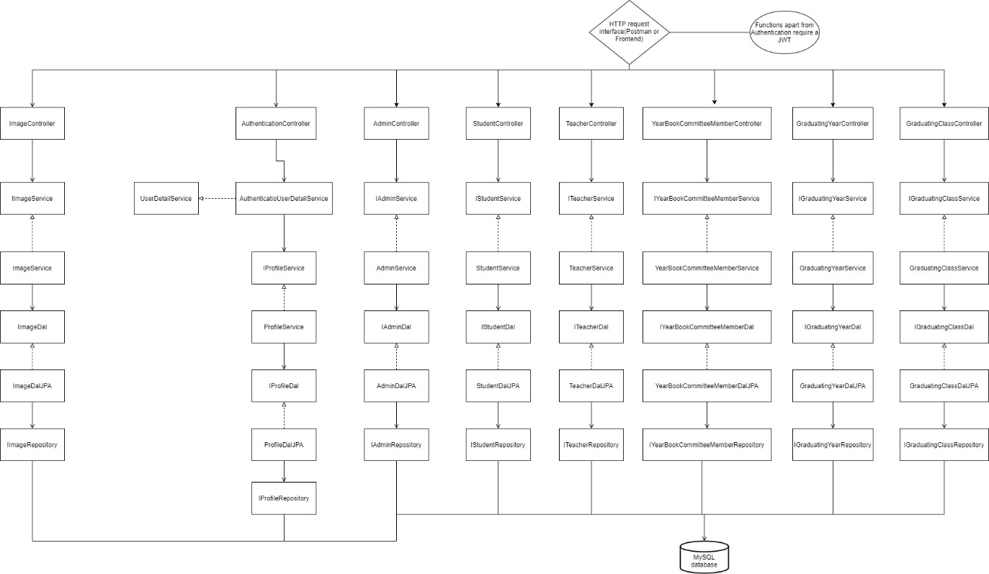

# Diagram Link

The link below is provided for better viewing:



Level4: Code structure and DB Design (UML, ERD)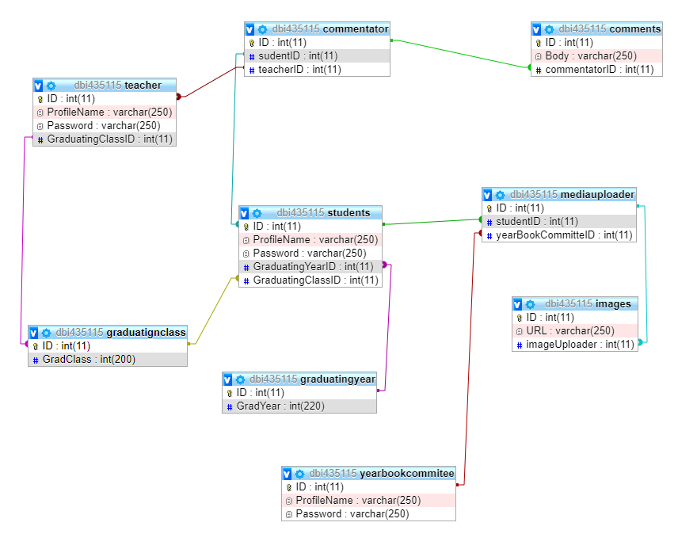

)

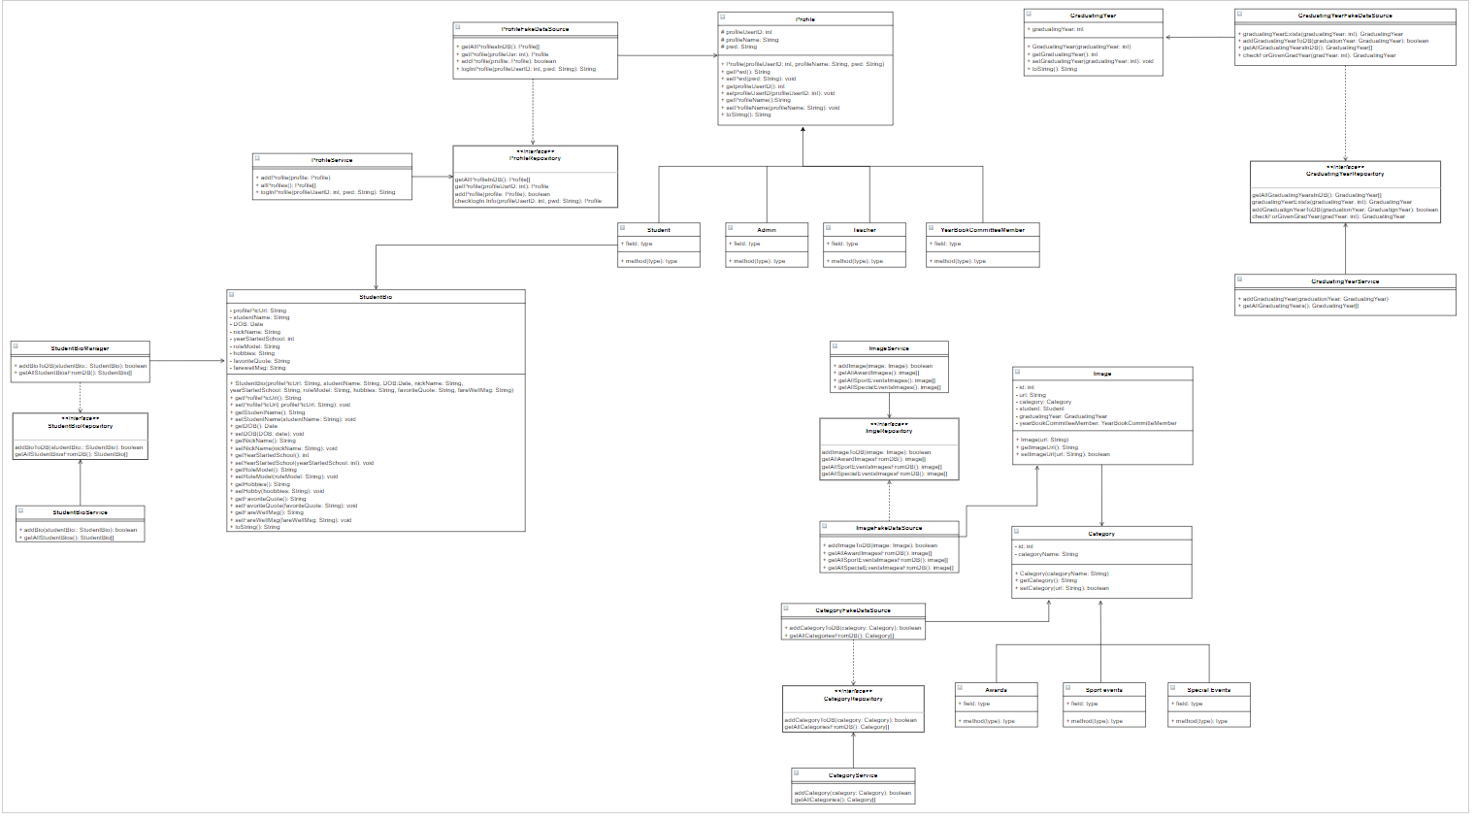

# Diagram Link

The link below is provided for better viewing:



# BackEnd Decisions

## Java Spring boot Framework:

Spring boot is the framework used in this application mainly due to it making production ready application easy to create, a good example is with spring boot there is an already embedded tomcat support which makes connecting to a database easier.

## BCrypt for encryption

After researching, I found that bcrypt is a password hashing system mainly used for encrypting passwords at a strong encryption level for storing in a database, therefore due to this application will be storing user personal details it has been integrated to ensure guaranteed safety.

## Hibernate

After researching, I found that hibernate make querying a database easier to it being an ORM tool rather than using JDBC CRUD queries, hibernates handles all the implementations of CRUD functions internally thus we can access them using API calls which makes production faster.

## Spring Security

After researching, I found that for authentication and authorization it is best to use spring security being that it already contains all the necessary functions for securing your api by using servlet filters that help add authentication and authorization to a web application and also it integrates well with my chosen Java framework Spring boot.

# References

Spring security

(MarcoBehler, 2020)

Spring boot

(Spring writier, n.d.)

BCrypt

(Accaputo, n.d.)

Hibernate

(Waseem, 2019)

# Sonarqube Screenshot (Quality assurance metrics)

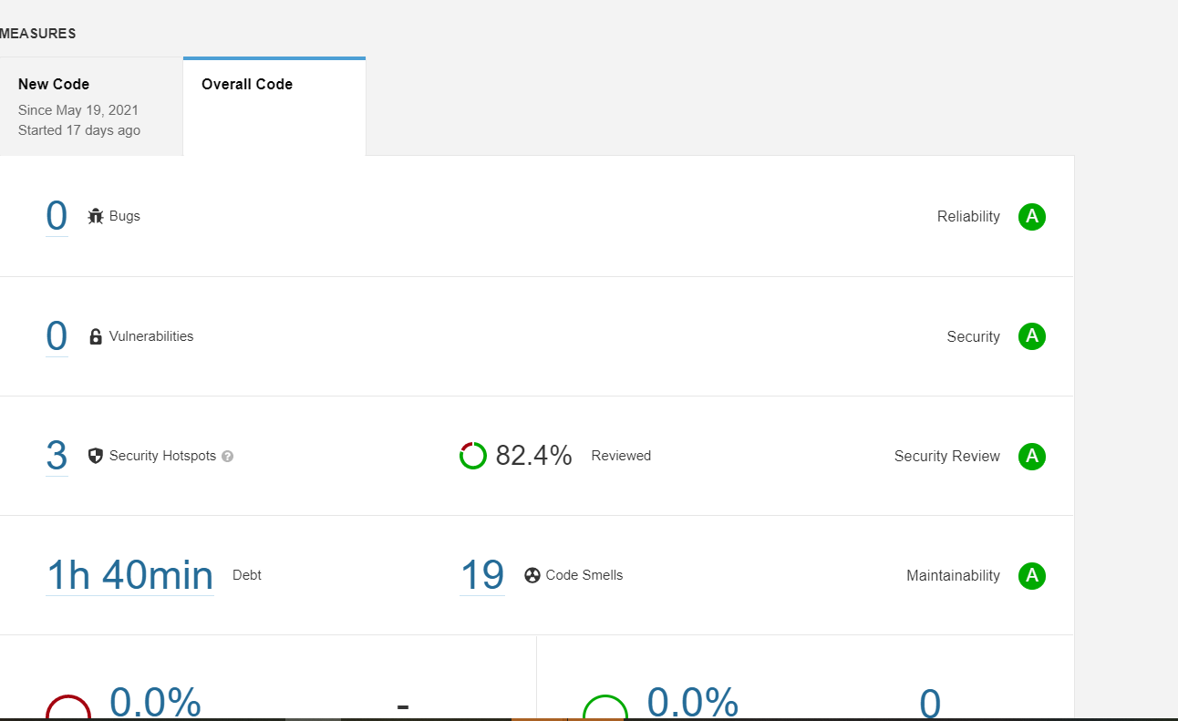

# CI CD Setup

